Apple Company
Student’s Name
Institutional Affiliation
Course Name
Professor’s Name
Assignment Due Date

A Sales and Income Record, to include sales and net income figures for 5 years--20xx-20xx and a graph displaying the trends.
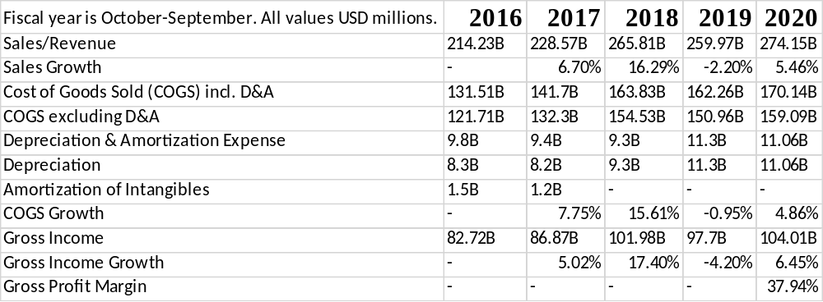
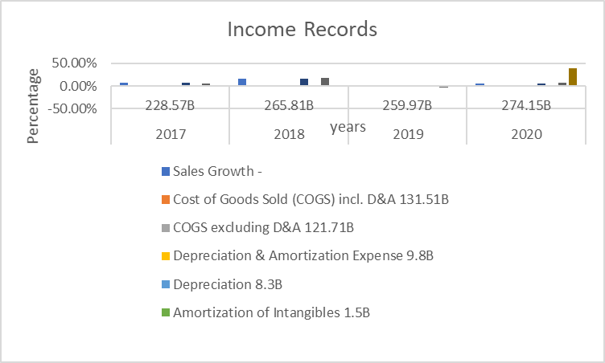
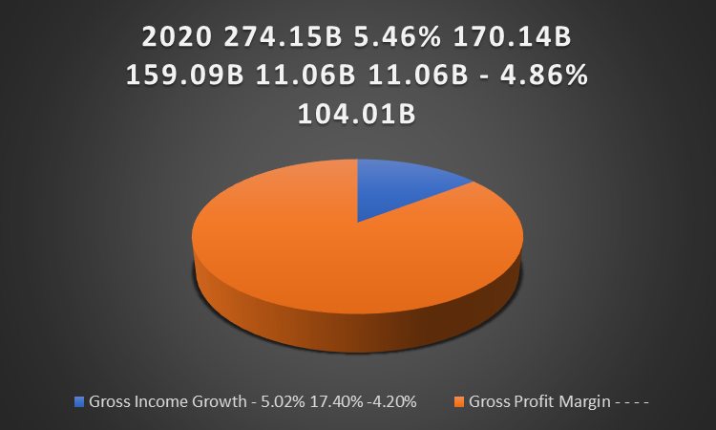
Within the five years, the Company's sales revenue has been increasing apart from 2019 when it slightly dropped by 2.20% but later increased by 5.46% this year 2020. This has also been happening to Apple's Gross income, which has been doing quite well until 2019 when it was slightly affected concerning the revenue but bounced back nicely this year 2020. Apple Company reported its fiscal Q4 2019 earnings, where they talked about earning a record $64 billion in revenue (up 2 percent year over year). The general trend with Apple over the previous year. The iPhone sales are down iPad and Wearables.
A list of the Company's major expenses for FY 20xx-the last available year and a pie chart showing the Expense Distribution.
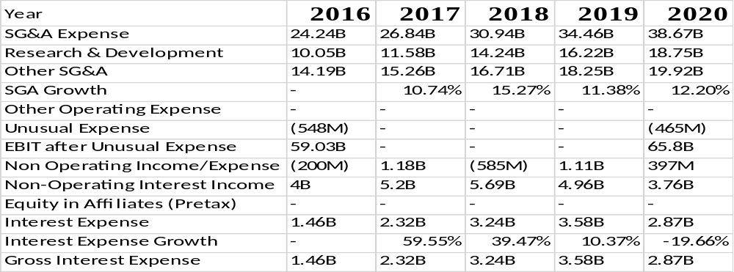
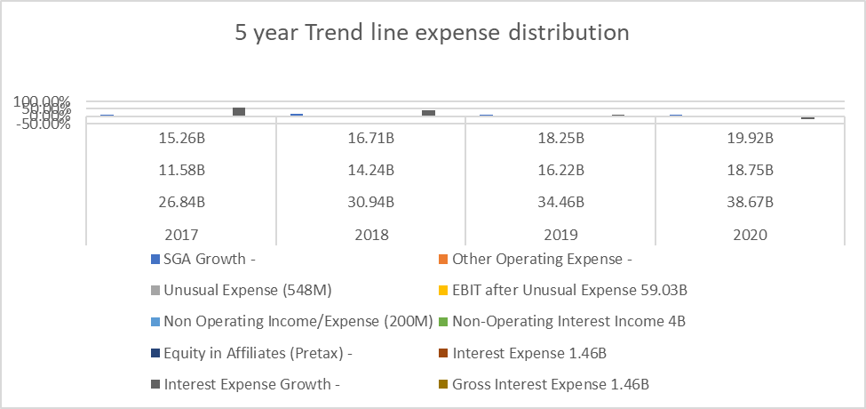
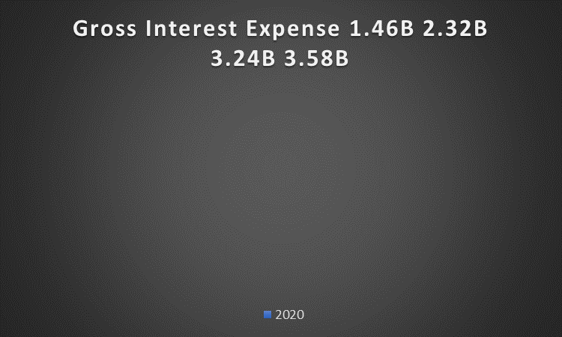
The expense distribution increases each year for five years. The lowest amount in 2016 rises in 2017, 2018, 2019, and 2020. The SGA Growth is also increasing with an increase in SG & A expense. The 2016,2017,2018,2019 and 2020 Gross Interest Expense 1.46B, 2.32B, 3.24B 3.58B and 2.87B respectively. Apple Company invested US$250.000 to distribute an effective network to its customers and provide them with effective feedback to become better. This Company also a variety of indirect distribution channels like R and D and Total expense, which was $10.0 billion, $8.1 billion, and $ 6.0 billion in the year 2016. It reviews its long-lived assets, which also includes capital assets.
A list of the Company's principal assets for FY 20xx-the available last year and a pie chart showing the Assets Distribution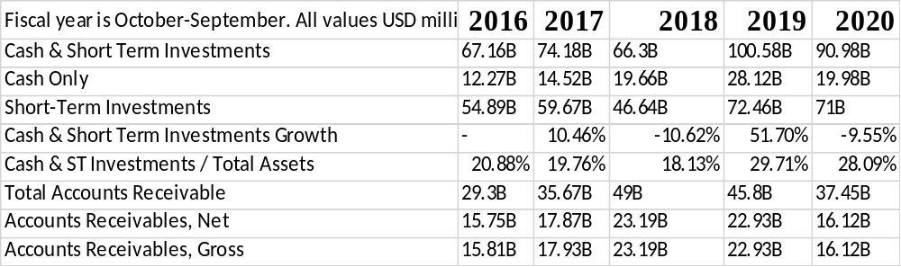
The assets distribution Cash & Short-Term Investments, Cash Only, Short-Term Investments, Cash & Short-Term Investments Growth, and Cash & ST Investments / Total Assets in 2016, 2018, 2017, and 2020 was low, unlike 2019, where it was slightly high. For the Fiscal Quarter Ended March 31, 2018.ASSETS: Current assets: Cash and cash equivalents. $. 45,059. $. 20,289. Except for the temporary impairment, the Company reviews factors like the distribution partners and the Company's customer’s location.
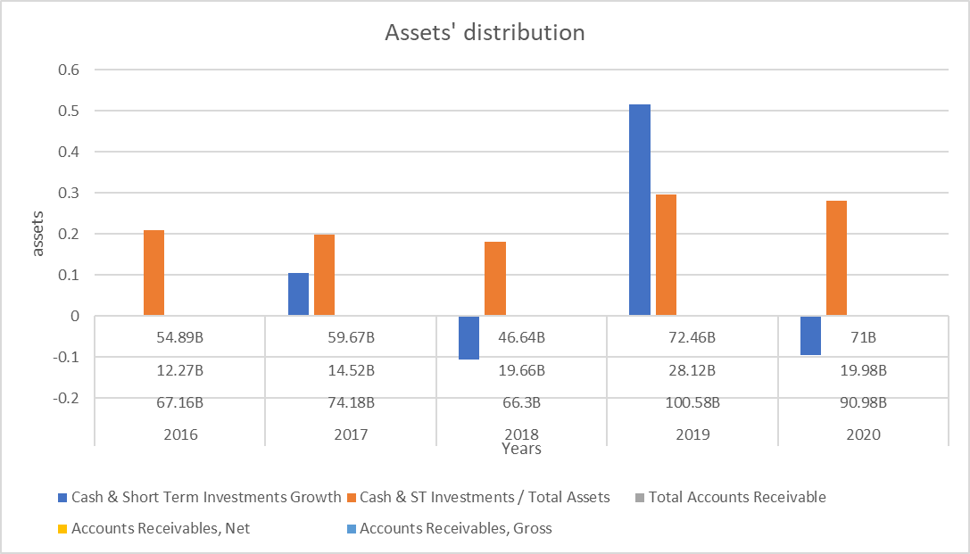
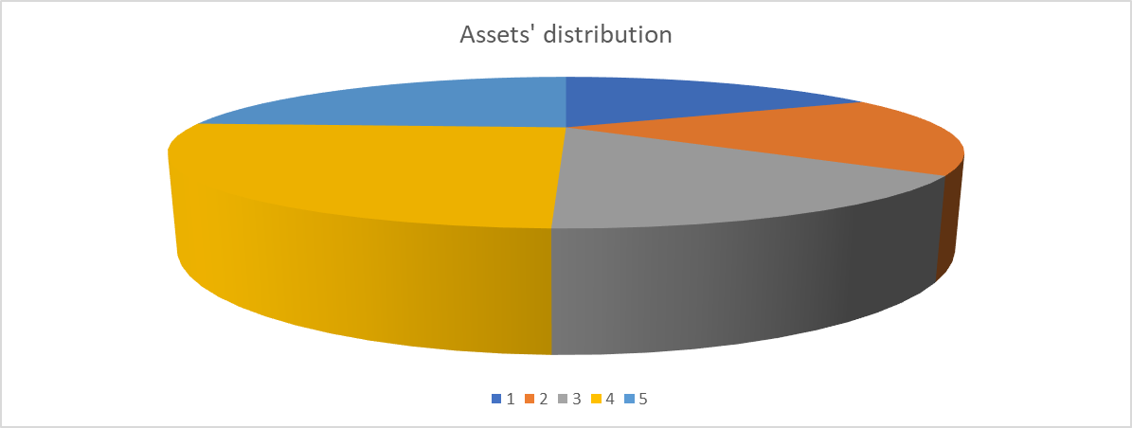
A list of the Company's significant capital accounts for FY 20xx-the available last year and a pie chart showing the Capital Structure
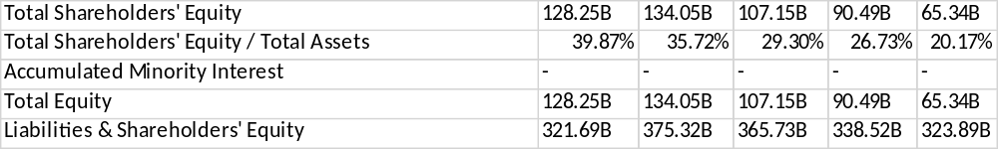
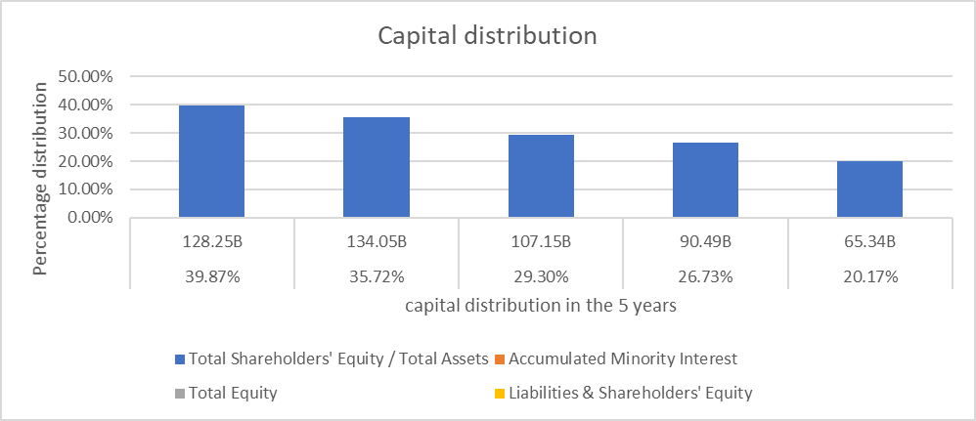
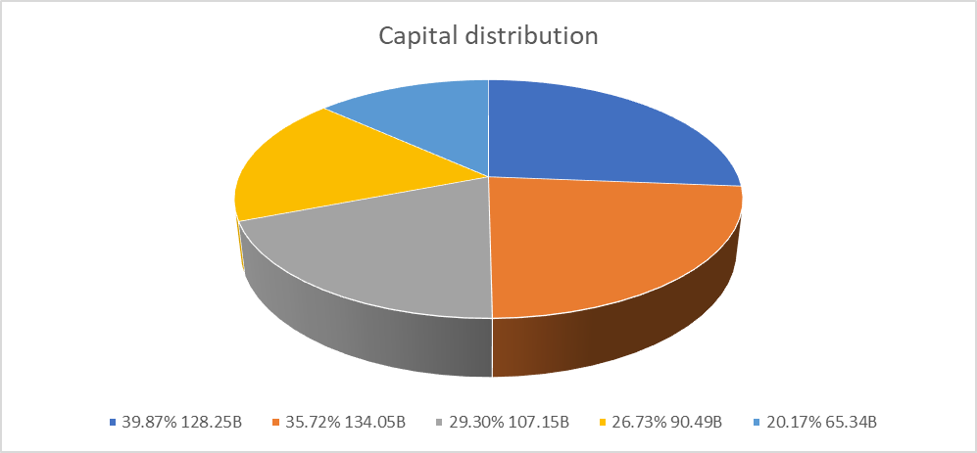
The Total Equity of the capital distribution was 128.25B, 134.05B, 107.15B, 90.49B, 65.34B for the five-year trend, which displays a drop each year. Apple paid $14.1 billion in dividends and spent $67.1 billion in fiscal 2019. The dividend tax is 50% higher than the capital gains tax. Apple Company recorded a report of U$50.78 billion in Ordinary Share Capital for its third fiscal quarter of 2020.
PART 3, TREND ANALYSIS: Use the most recent five years
Part a) Sales and Income Record:
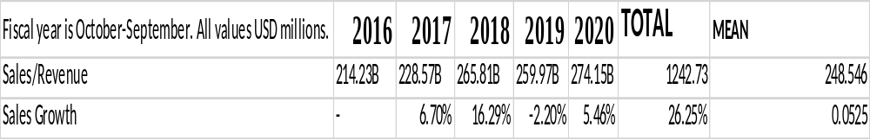
The sales growth in 2017 was the highest.
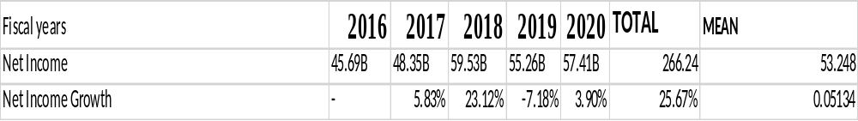
The Net Income Growth in 2018 was the highest.
Part b) Stock Price Record:
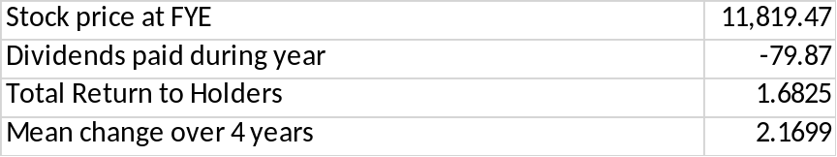
The mean change over the four years will be 2.1699.
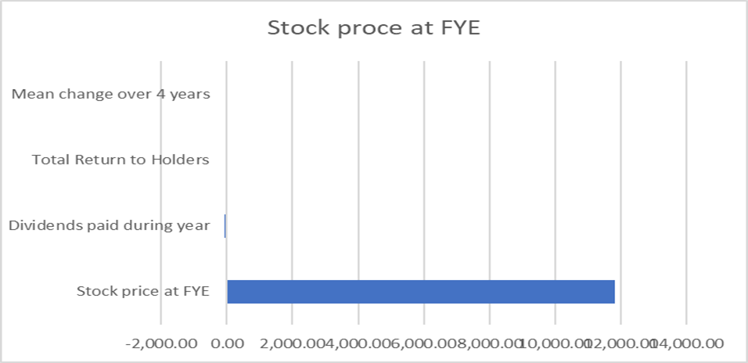
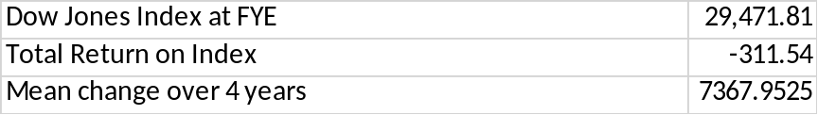
The mean change over the four years will be 7367.9525.
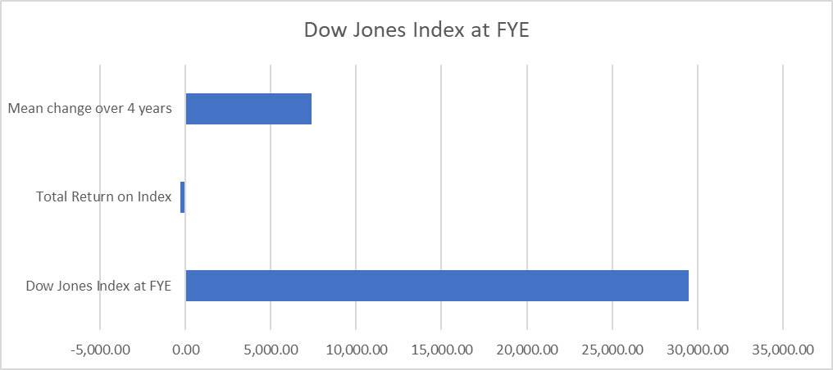
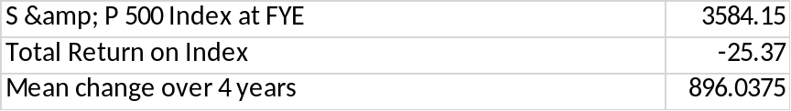
The mean change over the four years will be 896.0375.
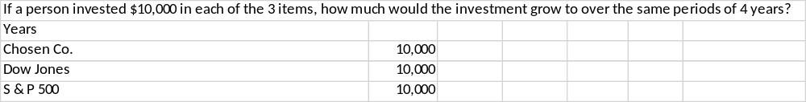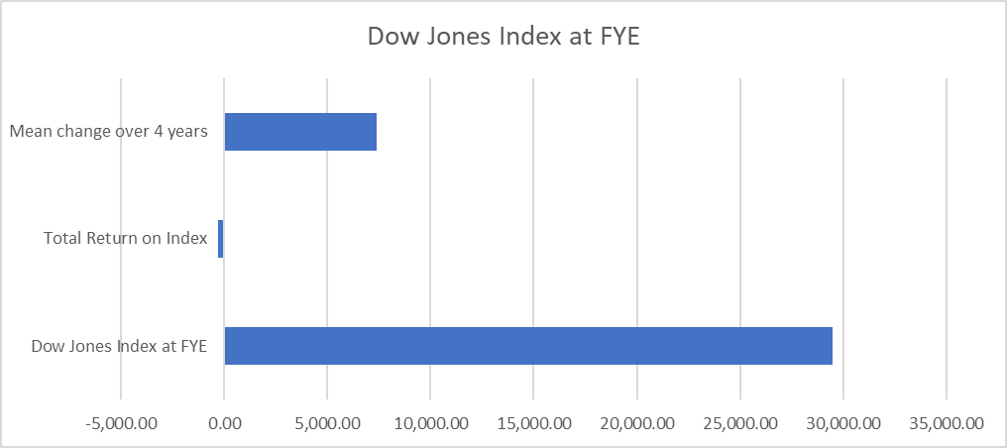
The investment will grow to $ 102,667.6 after four years.
Final Framework
Although Apple has been recording revenue and a cash flow of $50 billion, it is not a growth company anymore because of the single-digit revenue drop and double-digit iPhone decline. We have many reports from any sources stating that iPhone 11 sales made in September are better than last year. In 2015, the tech giant's revenue decreased from $244.7 billion to $217 billion in 2016, which covered a drop of 8 percent. This fall affects company sales and the essential Company, the iPhone (Arnold, 2018). The Apple company announced the financial results for its fiscal 2017 fourth quarter in California, on November 2, 2017, which ended on September 30, 2017. This Company also recorded $52.6 billion quarterly revenue, with a 12 percent increase from the previous year's quarter, and quarterly earnings per diluted share of $2.07, up to twenty-four percent.
Revenue of $62.9 billion was also posted by Apple Company for the fourth quarter, up to 20 percent from $52.6 billion during the same period last year, and $265.6 billion in revenue for full-year 2018, up 16 percent from $229.2 billion in 2017. On October 29, 2020, Apple announced its fiscal 2020 financial results for the fourth quarter that ended on September 26, 2020, in Cupertino, California (Li, 2020). The Apple Company also posted September quarter revenue of $64.7 billion and quarterly earnings per diluted share of $0.73. In their 2019 financial year, Apple's total net sales amounted to 260.17 billion U.S. dollars, a small drop from the FY2018 historical record of 265.6 billion U.S. dollars. In the last ten years, the Annual revenue in Apple has quadrupled. Apple might or not go anywhere any time soon. This is a growing company, and it is not 'dying' anytime. There is a more significant opportunity for creating more apple technologies in the world business. Some of the recommendations that I can give the apple company for it to continue growing are:
- Letting iOS devices automatically adjust to cars, offices, and homes.
- Whipping Siri into shape and releasing affordable Siri Speakers
- Making iPods relevant again.
- Improve MacBook Pro battery performance.
- Get real already with the Apple TV.
- Streamline the iPad, iPhone, and Apple Watch families.
- Reinvigorating the Apple accessory market.

References
Arnold, A. G., Ellis, R. B., & Krishnan, V. S. (2018). Toward effective use of the statement of cash flows. Journal of Business and Behavioral Sciences, 30(2), 46-62.
http://asbbs.org/files/2019/JBBS_30.2_Fall_2018.pdf#page=46
https://d1wqtxts1xzle7.cloudfront.net/54598195/International_Financial_Statement_Analysis.pdf?1506938427=&response-content-disposition=inline%3B+filename%3DInternational_Financial_Statement_Analys.pdf&Expires
https://dspace.vsb.cz/bitstream/handle/10084/140000/LIB0037_EKF_B6202_6202R010_2020.pdf?sequence=1
Li, B. (2020). Evaluation of Financial Risk in Apple Company.
Robinson, T. R. (2020). International financial statement analysis. John Wiley & Sons.

